Post Vendor Down Payments

S.NO. : 01- FI-AP- 01

TRANSACTION CODE : F – 48

ACCESS PATH :SAP Easy Access Accounting Financial
Accounting Accounts Payable Document Entry
Down payment Down Payment

We get “ Post Vendor Down Payment” Header data” screen ;

Required Fields:

Document date : To be entered
Account : To be entered (Vendor A/c Number)
Spl. G/L Ind. : To be set at “A” (down Payment on current asset)
Post date : Default
Amount : Total amount inclusive Bank Charges to be entered
Bank Charges : To be entered

Rest all other fields viz, Doc Type, Period, Companycode,Currency/Rate are default after they are entered for the first time.

We get the Screen “Post Vendor Down Payment - Header Data“ incorporating the above mentioned required fields as under;

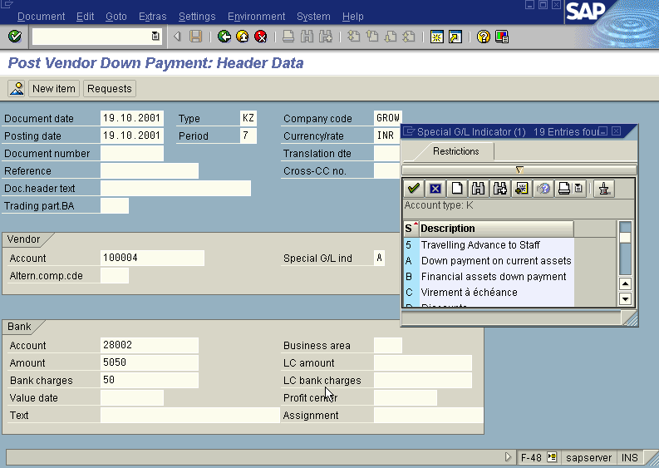

Press Enter button

A screen relating to the “Tax Data” will appear as under

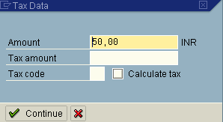

Press button

The system will display the below message

Press button

The system will display the below warning message.

Press button

Now we get the screen “ Post Vendor Down payment – Add Vendor Item” .

In this screen fill three fields –
- Amount (exclusive of bank charges )
- Due date
- Purchase Document
The screen is pasted hereunder along with the inputs in these three fields.

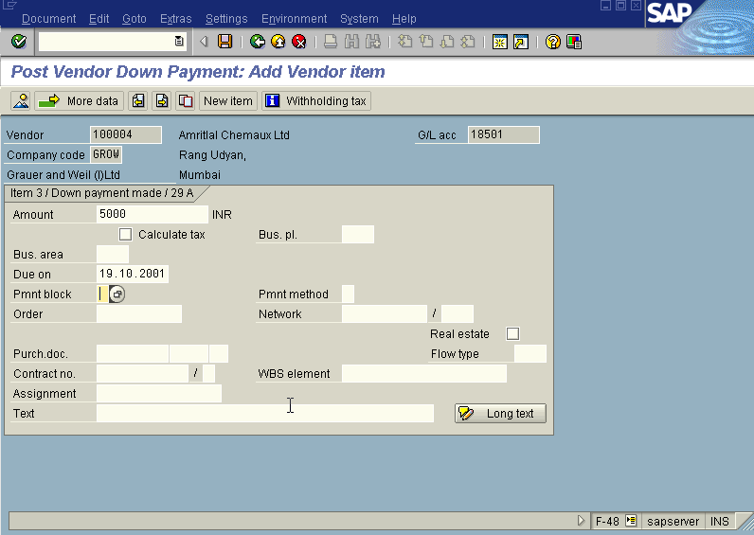

Press Enter button

We will be presented with “ Post Vendor Down payment – Correct Vendor Item”
Screen.

The payment block field in the above screen will show “A” (Blocked for payment) . The screen will appear as under.

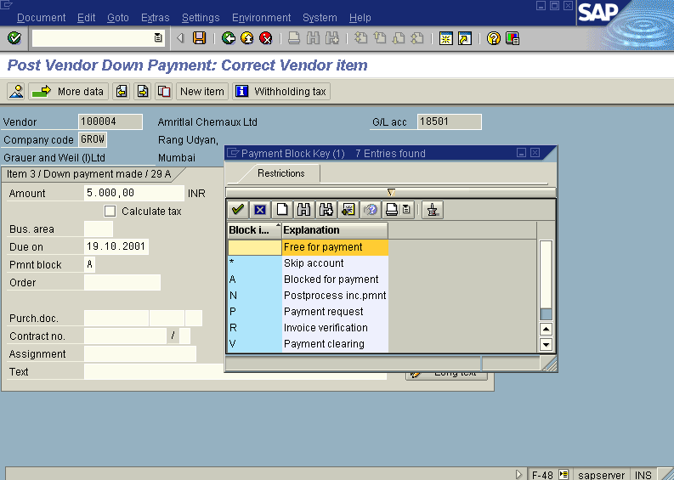

Press Enter button

Press Save button

The system will display a message as under

Take a note of the document number ; 1500090.

This is the stage where “Post vendor down payment” stage is complete

The document can be seen from Document Display from the top left hand side of the main screen “post Vendor down payment - Header Data“ OR from Transaction code FB- 03 .The Document overview screen will be displayed as under showing the entries.

